MTConnect .NET
Verifier User Guide
Version 0.1.0.1

Initial draft for review
Prepared for: AMT
Prepared by: Georgia Tech
Date: July 29, 2010

Table of Contents

Terminology 2
Overview of Certification documents 4
MTConnect Verifier Operation 6
How to install the MTConnect Verifier 6
How to configure 6
MTConnect Verifier Package Structure 7
General 7
Verifier 7
Verifier Configuration 8
How to Guide 9
How do I run an instance of the MTConnect Verifier? 9
Comments or Questions 10
Acknowledgements 10

Terminology

Adapter An optional software component that connects the Agent to the Device.

Agent A process that implements the MTConnect specification, acting as an interface
to the device.

Application A process or set of processes that access the MTConnect Agent to perform some task. An example would be a monitoring application that graphs spindle speed.

Attribute A part of an element that provides additional information about that element. For example, the name element of the Device is given as <Device
name=”mill-1”>...</Device>

Component A part of a Device that can have sub-components and data items. A component is a basic building block of a device.

Device A piece of equipment capable of performing an operation. A device is composed of a set of components that provide data to the application. The
device is a separate entity with at least one Controller managing its operation.

HTTP Hyper-Text Transport Protocol The protocol used by all web browsers and web applications to communicate over the internet or intranet.

Introduction
MTConnect is an open communications standard developed to facilitate the exchange of data on the manufacturing floor from machine tools and sensors. These machines tools such as lathes, CNC milling, laser cutting, waterjets, etc. and other computer controlled machines allows plant managers and applications to monitor activities, focus on process improvements, and respond to alarm conditions in a more timely fashion.

Further definition of the MTConnect open communications standard can be found at the MTConnect website: http://www.mtconnect.org/. The latest MTConnect Agent MTConnect Verifier can also be found under Downloads.

This document describes the Agent Verifier that was built on Microsoft .NET technology which can be used to verify an MTConnect Agent functionality. The MTConnect Verifier uses the NUnit open source unit testing framework for Microsoft .NET using C#. NUnit serves the same purpose as JUnit does in the Java world, and is one of many in the xUnit family.

It is typically recommended that the application architect or analyst write all the unit test cases upfront and test the developed code against these cases and functionalities. The main advantage is a well defined deliverable and more quantifiable progress.

This may not be applicable if the analyst has already written the MTConnect Agent or the analyst has designed the MTConnect Agent to be run on other than the Microsoft .NET platform. This issue is resolved by utilizing an external environment (MTConnect Client Application). Think of the MTConnect Verifier as an application that checks any MTConnect Agent externally similar to the “black box” testing mythology. Since the MTConnect Agent uses HTTP this makes external testing very simple.

The MTConnect Verifier runs a defined set of test cases against any MTConnect Agent that was designed using the MTConnect 1.0 standard. It uses a graphical user interface that indicates the test id, description and a color indicator for pass, fail or no test.

The various test cases used in the MTConnect Verifier are based upon the MTConnect Certification Working Group’s documents. The Certification documents were divided into 8 separate documents based upon content sections. The Certification Working Group has defined the certification conformance based upon the MTConnect 1.0 standard.

The following picture provides an overview of the .NET MTConnect Verifier:

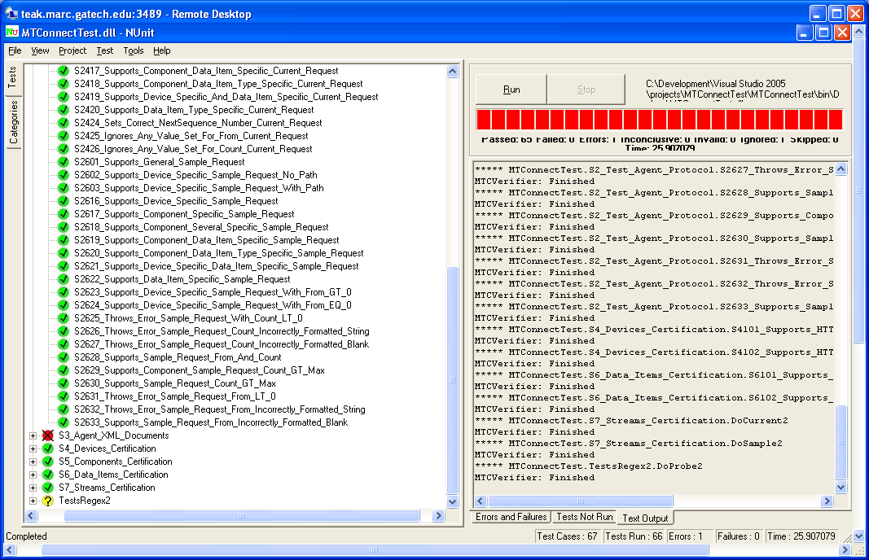

Figure 2. A screen capture of the MTConnect Verifier showing test cases and results

A screen capture of the Microsoft .NET MTConnect Verifier, shown in figure 2, illustrates a few of the test cases during the testing process. The left-hand side shows the test cases and their results. The right-hand side shows the test messages statistics.
The green checked icon in front of the test case show the test passes the exam and the red icon shows a failure. The yellow icon illustrates a test case that could not be performed.

The test cases run on the Verifier are divided into the eight (8) Certification documents.
The structure of the test cases are named according to the document section and the test case number. Below is the current organization of the Certification documents:

Overview of Certification documents
1 Agent – Certification – General Setup
2 Agent – Protocol certification
3 Agent – XML Documents certification
4 Agent – Devices certification
5 Agent – Components certification
6 Agent – Data Items certification
7 Agent – Streams certification
8 Agent – Unit Conversion certification

An example of a certification test case is provided below:

1.8.1.1 All Agent responses are valid and well-formed XML docs: probe request (latest schema)
Priority: High
Setup:
see General setup for all XML documents-specific certification testing above (section 1.6)
XML validation tool
Access to latest MTConnect XML schema for MTConnectStreams
device: choose simplest one, Setup 1: LinuxMin
Test Data: a probe request: http://<machine IP>/probe
Steps: TApp sends the current request to Agent
ExpResult:
Agent successfully receives the request from the App (HTTP response code: 200)
Agent responds with a valid MTConnectStreams XML document which passes all validation checks for:
- each element has a closing tag
- no illegal characters are contained in the doc
- all required elements and attributes are present
- all elements and attributes only occur the correct number of times

The test case structure in the Verifier for this test case is based upon the document number (3) as “Section 3” and the test case number (1.8.1.1) translates to (101) since the 1.8 has no meaning. Therefore the test case number is S3101. We next need to give the test case a name and here we shorten the description and would look as such:
/****************************************************************************
//Section 3 Agent – XML Documents Certification
/****************************************************************************
[TestFixture]
public class S3_Agent_XML_Documents
{

//S3.1.1 All Agent responses are valid and well-formed XML docs: probe request (latest schema)
public void S3101_Agent_Responses_Well_Formed_XML_Docs()

MTConnect Verifier Operation
The MTConnect Verifier can be utilized in several different architectural scenarios as described previously, so please chose a scenario that best fits your development and controller interface needs.

How to install the MTConnect Verifier
To install the MTConnect Verifier, please do the following:
- Log on to the target computer with an account that has administrator privileges.
- If you want to modify the MTConnect Verifier you will need to install Microsoft Visual Studio 2008 on your PC.
- If the Microsoft Dot.NET Framework Version 2.0 (or newer) Redistributable Package is not installed on the target computer, it will be need to be installed on your PC.
- Run an “unzip/open a compressed folder” of the “MTConnect Verifier-v0.1.0.zip” which was included in the installation media or via a download. The resulting uncompression Wizard will guide you through the installation process and establish the MTConnectVerifier directories providing you with the solution/ project.
- Change into the \dist folder.
- Copy the MTConnectVerifier directory to C:\
- Change into the C:\MTConnectVerifier directory.
- Modify the mtcverifier.ini details to the MTConnect Agent you wish to test.
- Double click MTConnect Verifier shortcut (you can copy it to your desktop).
- Click on Run. It will take a couple of minutes to run all the tests.

How to configure
To configure the MTConnect Verifier, please do the following:
- Make sure that the MTConnect Agent software application is available and operational for the Verifier.
- Edit the mtcverifier.xml file for your MTConnect Agent. The files are located in the installation directory (this is the directory where MTConnectVerifier.exe is located). Modify the devices and URL as required for your implementation. Information about the configuration file can be found in the Configuration File section of this document.
- Save and close the configuration file.

MTConnect Verifier Package Structure
The MTConnect Client MTConnect Verifier is delivered as a zip file which contains the following directories:

General
\
This is the root directory which contains a readme file. The readme file contains a brief description of the directory listing.

\dist
This is the directory that contains the distribution for running the Verifier independently.

\doc
This directory contains the MTConnect Verifier documentation.

\src
This is the source directory that contains the Visual Studio solution and projects.

Verifier
\src\MTConnectVerifier
This is the solution directory. It contains the MTConnect Verifier solution file and the project directories which include all the source code.

Verifier Configuration
Upon startup, the verifier configures itself based upon values in the configuration file. The configuration file is an xml file named mtcverifier.ini, contains elements as listed in the table below and adheres to mtcverifier.xsd schema. Both files are located in the same directory as the exe or DLL file being used.

Configuration File Elements
Element Name | Description | Usage
Company | The Company name used in the LDAP entry. | A string that contains only letters or numbers.
DeviceName | The name of the MTConnect Device. | A string that contains only letters or numbers.
Description | The LDAP Description of the Device. | A valid string.
DeviceURI | The MTConnect URI for the device. | A valid URI to the MTConnect Agent.
CreateNewLogFile | Should the old log file be deleted and new on started? | true or false (case insensitive)
UseLogFile | Should debug items be logged to a file? | true or false (case insensitive)

How to Guide

How do I run an instance of the MTConnect Verifier?
- Make sure the Microsoft .NET Framework 2.0 or newer is installed on your computer (See www.Microsoft.com and click on downloads).
- Unzip the MTConnect Verifier file.
- Change into the \dist folder.
- Copy the MTConnectVerifier directory to C:\
- Change into the C:\MTConnectVerifier directory.
- Modify the mtcverifier.ini details to the MTConnect Agent to test.
- Double click MTConnect Verifier shortcut (you can copy it to your desktop).
- Click on Run. It will take a couple of minutes to run all the tests.
- Review the results.

Comments or Questions

Please contact:

Andrew D. Dugenske
Manufacturing Research Center
Georgia Institute of Technology
dugenske@gatech.edu
+1 404 894 9161

For Technical Issues:

Douglas A. Furbush
Manufacturing Research Center
Georgia Institute of Technology
doug.furbush@marc.gatech.edu
+1 770 316 1636

Acknowledgements
Funding and technological guidance for the MTConnect verifier was provided by:



TechSolve
6705 Steger Drive
Cincinnati OH 45237
www.techsolve.org

